# **Module:** AIDM7410 Computational Journalism

**Assignment:** Final group report

**Topic:** Travis Scott stampede at Music Festival

**Group members:**

21419914 ZHANG YUXUAN

21460272 QIU MINGYANG

21448108 CAI JING

21435014 WEN QI

**Tutor:** Dr. ZHANG Xinzhi

**Date of submission:** 13 December 2021

**Introduction**

Rap originated in the mid-1970s in the South Bronx, New York, and is a black slang word equivalent to "talking", which means rapping in Chinese, a special form of singing that refers to rhythmic speech. It originated in the poor black neighborhoods of New York. It is characterized by the rapid delivery of a series of rhyming verses against a backdrop of mechanical rhythmic sounds. Rap, a niche area of music, continues to grow and become better known today, and Our project is about Travis Scott, an American rapper and music producer. Travis Scott was thrust into the spotlight after the Nov. 9 stampede. Have things settled down yet? Did fans understand his apology? Our project looked at his Twitter feed, grabbed the data and analyzed it based on social networks and fan bases. Travis Scott analyzed it in combination with his song sales and YouTube views. Our project can take the audience to understand him in a more visual and three-dimensional way.

**Background**

A stampede of fans during rap star Travis Scott's Astroworld event on Nov. 9 killed nine people between the ages of 14 and 27 and injured scores. As Scott continued to perform, two teens, ages 14 and 16, got caught up in the raging crowd and finished his set even after noticing that fans were being treated. Scott, a headliner and hometown star who founded Astroworld Music Festival in 2018, later said he was unaware of the severity of the situation.

Houston city police chief Troy Finner said his department had opened a criminal investigation by homicide and narcotics detectives, following reports that somebody in the audience had been injecting people with drugs.One security guard felt a prick on his neck, passed out, and was revived after being injected with Narcan, a drug used to treat opioid overdoses, Finner said. Several others were treated with Narcan, according to the city's fire chief, Samuel Pena.Harris County Judge Lina Hildago also called for an "objective, independent" investigation of the rap festival attended by 50,000 people.

"Perhaps the plans were inadequate. Perhaps the plans were good but they weren't followed," Hildago said. "The families of those who died, everybody affected, deserves answers."Houston Mayor Sylvester Turner also called for a briefing from all the parties including first responders, concert promoter Live Nation, and officials of the venue, NRG Park.The first lawsuit in the case has been filed. Manuel Souza, who suffered "serious bodily injuries" at the show, is seeking at least $1 million in damages from a host of defendants including Scott and Live Nation, according to a petition filed in Harris County District Court.Neither Scott's representatives nor Live Nation immediately responded to requests for comment on Sunday night.The victims were killed near the stage when the crowd surged forward, with some suffering cardiac arrests and other medical trauma, officials said.

**Questions**

There are two questions we would like to explore about this event. The first is have things settled down yet? The second is did fans understand his apology?

**Methodology**

Our project aims to look at Travis Scott’s twitter feed after the stampede at the Astro World Music Festival. We will start from crawling and grabbing the data, and analyze it based on social networks and fan bases. Then we will focus on both Travis Scott’s song sales and YouTube views after this tragedy happened. By doing so, our project will be able to give the audience a more visual and multi-dimensional understanding of him. In this project, the crawling and visual presentation are mainly done by using Python. In addition, we will use planned behavior theory and conduct online experiments on github based platform.

**Analysis**

***Personal information***

Jacques Bermon Webster II, also professionally known as Travis Scott and Travi$ Scott, was born in Huston, Texas, U.S. on April 30, 1991. He is a famous rapper, singer, songwriter and record producer. His music genres are mainly hip hop, trap and alternative hip hop. Travis has his own twitter account(@trvisXX) created in April, 2010, with 690 people following and 11.4 million followers.

***Awards and nominations***

As a popular rapper and singer, Travis has obtained huge achievements during his dream-chasing time in the road towards music. His *Owl Pharaoh* was nominated by the BET Hip Hop Awards 2013 with the category of best mixtape, but unfortunately didn’t won the prize at last. This was Travis’s first time to be nominated in a music award. From the year 2013 till now, Travis’s music have been nominated by 31 different awards for 64 times and 8 of the won the award at last, one of them is still pending.

***Songs***

The music platform we use was sportify, which is a Swedish advertisement streaming and media services provider. It is one of the world’s largest and most famous music streaming service provider, with over 381 million monthly active users. When we input “travis scott” in the searching box in spotify, we can see that he has 1.55 million followers and other information in his home page. By viewing Travis’s song list, we found out that most of his song playbacks are over million times, some are over tens of millions of times and some even reached more than one hundred million times. Take his *ESCAPE PLAN (official music video)* as an example, it had been viewed 11,758,418 times last month on spotify. And Travis has 45,379,582 monthly listeners, ranking the 22th in the world.

**Results and Conclusion**

***Twitter analysis***

After grabbing information from Scott’s twitter account, we input these data into Jupyter Notebook and analyze them. The results are shown blew.

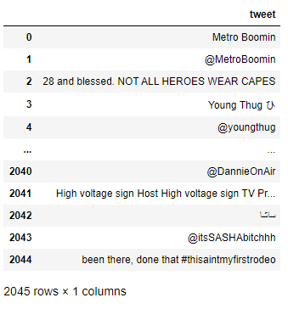 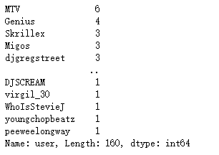

The first graph shows Scott’s twitter text and the second one shows how many time did these accounts, which are friends of Scott, mentioned by him in his tweets. As we can seen from Scott’s twitter text in the result, most of texts contain mentioning and the account which mentioned most by him is MTV.

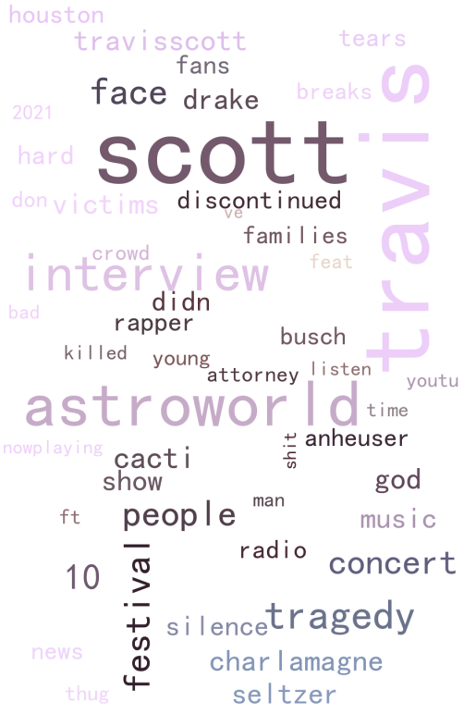 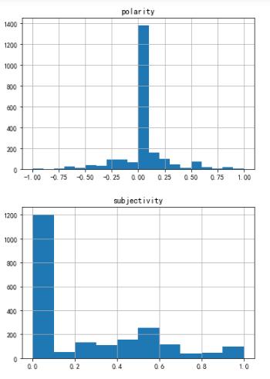

We also used keyword analysis to analyze tweets about Scott after the tragedy. We used python to generate a word cloud of total 2205 tweets. From the word cloud we found that except Scott’s name, the most frequently occurred words were astroworld, interview, festival etc, which all related to the tragedy. Besides the chart, we also used the texts to analyze these users’ emotions and attitudes toward this incident. From the two bar charts we can see that most of the people on the internet remained neutral and objective toward Scott and the tragedy.

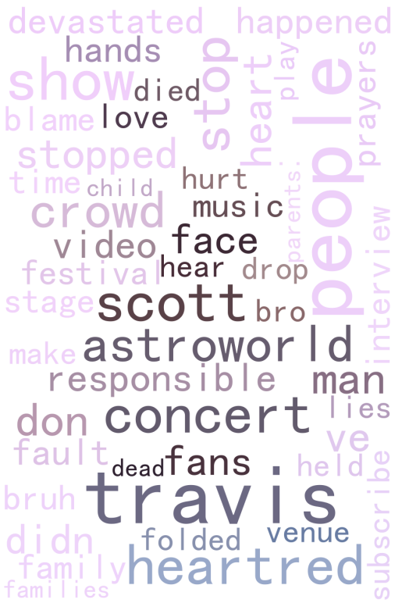 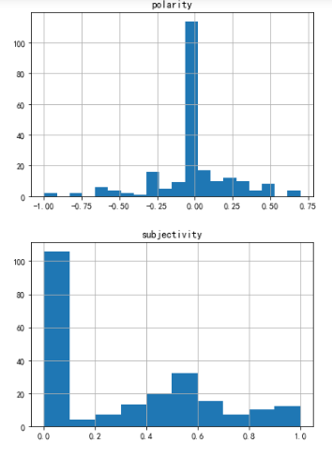

After the tragedy happened, Scott had post an apology on twitter. We also extract the keywords and made a word cloud for further analysis. The chart shows that the words he mentioned most were astroworld, concert, heartred, people, responsible etc, which we can see he feel sorry about such a horrible thing happened in his concert. Blew the post, there were huge amounts of comments and we also use emotional analysis to find out whether there is something different compared with our previous analysis or not. From the two bar charts we can see that people this time were more subjective and negative, because they may be impulsive when seeing the tweet.

***YouTube analysis***

Since YouTube is a famous video website overseas, we also analyze Scott’s playback volume of the last ten videos in order to find out if the incident affects his video playback volume. We generated a line chart to see the variation trend of playback volume of Scott’s last ten videos. From the chart we can see that the variation trend reaches its peak 10 month before, which is nearly 3 to 4 times of the other figures. So it is obvious that the tragedy do has a huge influence on Scott’s video playback volume.

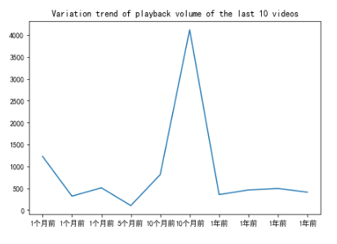

In conclusion, after preliminary work, we found out that most people can keep a neutral and objective attitudes toward Scott and the tragedy. And this incident indeed has influence him a lot and Scott also feel sorry about it.

**References**

Coscarelli, Joe (November 8, 2021). ["Before the Astroworld Tragedy, Travis Scott's 'Raging' Made Him a Star"](https://www.nytimes.com/2021/11/08/arts/music/travis-scott-astroworld-concerts.html). The New York Times. Retrieved November 16, 2021.

["2013 BET Hip Hop Awards: The Complete Winners List"](http://www.mtv.com/news/1715658/bet-hip-hop-awards-2013-winners/). Mtv.com. [Archived](https://web.archive.org/web/20171122040323/http://www.mtv.com/news/1715658/bet-hip-hop-awards-2013-winners/) from the original on November 22, 2017. Retrieved October 24, 2016.

["Spotify UK revenues surge to almost £190m as mobile subscriptions take off"](https://www.theguardian.com/media/2016/oct/14/spotify-uk-revenues-surge-to-almost-190m-as-mobile-subscriptions-take-off). The Guardian. 14 October 2016. Retrieved 6 August 2021.

["Company Info"](https://newsroom.spotify.com/company-info/). Spotify For the Record. 27 October 2021. Retrieved 27 October 2021.